**VS CODE e-Project**

KITCHEN APPLIANCES

**Submitted To**

[eprojects@aptech.ac.in](mailto:eprojects@aptech.ac.in)

**Project Instructor**

Miss Ayesha Ali

**Curriculum Code**

6740

**group members:**

*Abdalullah Sheikh*

*Student*

*Ahmad Zafar  
Student*

*Ahsan Khan*

*Student*



# KITCHEN APPLIANCES



**By Clicking on that button you will reach the**

**appropriate site. This is Product Site……**

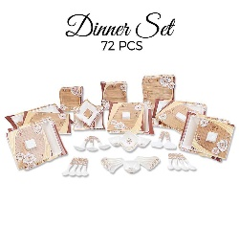Dinner Set

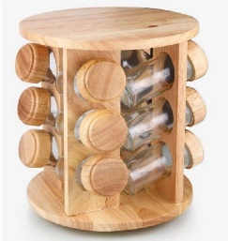 Spice Jar

By clicking on this you will reached the giving product page, where all products of that brand are present,…

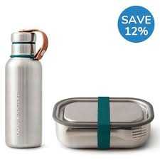Bottle and Lunch Box

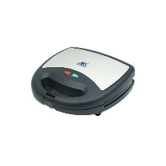Sandwitch Maker

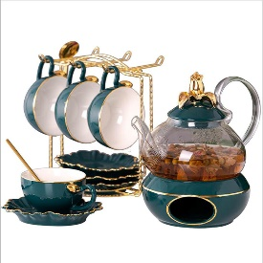 Tea Set

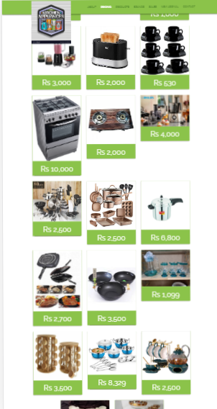

*Cooking pots*

*Cookware*

*Frying Pans*

*Freezers*

*Refrigeration*

*Refrigerators*

*Flask*

*Food Storage*

*Storage Bags*

*Spice Jars*

**PRODUCT**

Page

*Vacuum bottles*

*Lunch Boxes*

*Toasters*

*Electric Kettles*

*Food Choppers*

*Ice-Cream and sorbet makers*

*Egg Poachers*

*Steamers*

*Kadais [Karahi]*

**HOME PAGE:**

CLICK ON "HOME" PAGE & HOME PAGE WILL BE APPEAR……

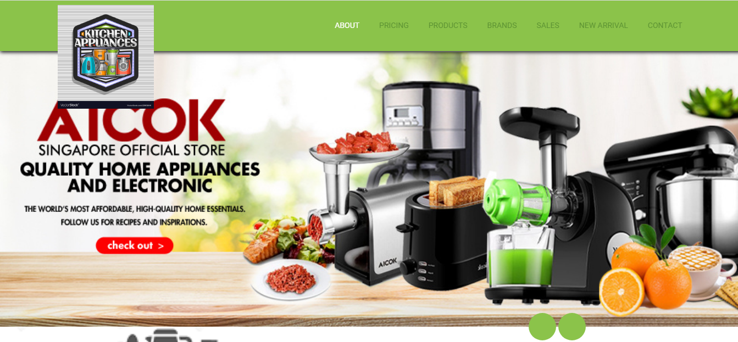.

**CONTACT US PAGE:**

CLICK ON "CONTACT US" PAGE & PAGE WILL BE APPEAR……

